GAD415 Readings & Assignments: Week 3
Week 3 Reading
Complete the following reading early in the week:
- Week 3 online lectures.
- From the textbook, Modeling a Character in 3ds Max:
  - Chapter 11: Optimizing the Mesh
Optional Reading:
  - Chapter 6: The Torso
  - Chapter 7: The Legs
  - Chapter 8: T he Back, Neck, and Shoulders
  - Chapter 9: The Arms
  - Chapter 10: The Boots
- Review the textbook 3ds Max 2010 Bible, as needed to reinforce and expand on the concepts and techniques required for this week’s assignments.
Week 3 Assignments Overview
Assignment Summary: Week 3 | Due Date
Assignment 1: Discussion Questions | Tuesday, April 20, 2010
Assignment 2: Final Project—Modeling the Body | Tuesday, April 20, 2010
Assignment 3: Final Project—Making the Props | Thursday, April 22, 2010
Assignment 4: Reducing the Polygon Count | Saturday, April 24, 2010
Assignment 5: Exploring 3ds Max | Saturday, April 24, 2010
Using the navigation on the left, please proceed to the next page.
Please post FBX files as well as Max files when you submit your assignments. This will help your classmates using older versions of the software to offer feedback on your work. Other compatibility problems can arise, and FBX files are a good solution. Rather than save, choose export to create an FBX file.
- Todd
Be sure that you’re counting tris in your model, and not polys!
Many of you are pressing 7 on your keyboard to get a polygon count. By default, this gives you a count of polygons, not tris.
To get a count of the tris in your scene, click on the + in the upper left corner of the viewport, and choose Configure. In the Statistics panel, check Triangle Count. I also like to check Total + Selection.
- Todd

Week 3 Overview
Last week, you revisited the box modeling techniques and methods to select and manipulate vertices. You also covered in detail the difference between edit-mesh modifier/editable mesh objects and editable poly/edit poly modifiers. You also learned about the polygon counter and how to use it. Finally you learned about the symmetry modifier and the difference between Meshsmooth andMSmooth modifiers.
This week you'll discuss the most important aspect of low-poly modeling. You'll discuss in detail various polygon reduction techniques. You'll learn about the 3ds Max modifiers like optimize and multires and manual techniques like weld, remove and delete, and controlling polygons in loft objects.
If you wish to revisit various spline modeling techniques, go through the first two lectures.
Let's get started!
Learning Outcomes:
- Conceptualize 3D coordinate systems and construct 3D models.
- Employ preplanning comps and model layout sheets.
- Create low poly models using box modeling techniques.
- Adjust polygon count based on changing requirements.
- Control polygonal face count through the various object parameters, such as segments and sides of primitives, path and shape steps for loft objects and tessellation controls for some modifiers.
- Demonstrate uses of the MultiRes modifier to reduce the complexity of models.
- Demonstrate uses of the optimize modifier to reduce the complexity of models.
- Create libraries of objects for props and character parts.

Spline Modeling Techniques—A Review
In spline modeling, you draw 3D lines or editable splines in the viewport. You then use the splines in a variety of ways to create 3D models. You can draw the spline in the viewport over the viewport background or texture-mapped plane and then use that new spline as a guide for your box-modeling. Alternatively, you can add modifiers to the spline to extrude, bevel, or lathe it, turning the line into a surfaced object.
The Loft compound object in 3ds Max lets you place shapes along a path and build surfaces between the shapes using a technique called lofting. You can also extrude polys along a path inside Editable Poly objects by using Extrude along Spline. You can also draw a cage of 2D splines using the CrossSection modifier, and then surface the cage by adding a Surface modifier to the stack.
A Word of Caution
All the images used in this course are based on 3ds Max 7. While a different version could change the images and screenshots, the concepts being taught are the same.
[Read Lecture on Spline Modeling techniques PDF]

Polygon Reduction Modifiers
The best technique to reduce polygons is not to add the polygons in the first place. But that isn't always possible. Often, you are handed assets that have been modeled by someone else, who might not have done everything correctly. You might be given models that have been modeled in other programs and imported by translators that created a lot of polygons. Or, your model might even have been generated from point cloud data from a 3D scan. In any case, you'll need to take that model and bring it into the limits of usability as per your game engine requirement. One way to do this task is to use polygon reduction modifiers. TheOptimize modifier and the MultiRes modifiers are each suited to the task.

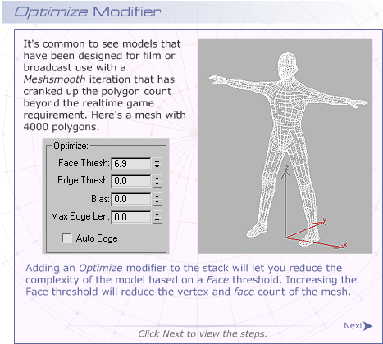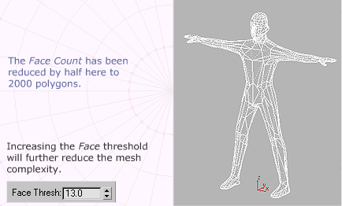
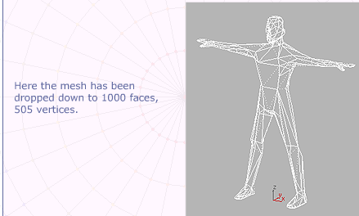


It's not very likely that this model will animate properly, since the Optimize modifier doesn't know the mesh needs to bend at the knees and elbows. It is mathematics that yields this new optimized mesh. Optimizing a model just gets you down to the polycount goal faster than doing it by hand or creating a new mesh from scratch. There'll always be some rework and refinement needed, but the process is much quicker than building the model from scratch.
You can also assign the Optimize to a subobject selection of the character's mesh. The legs won't be ever seen in close-up in the game, so you could use higher optimization on the legs than the upper body and head, by applying the modifier operation to the red selection below.
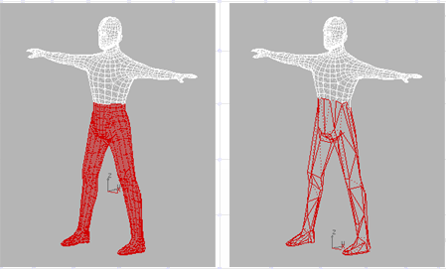
MultiRes Modifier
The MultiRes modifier gives you a more direct method to obtain your polygon budget. Select the mesh that you want to reduce in polygon count. Then, apply theMultiRes modifier. All the resolution parameters are grayed out and unavailable.
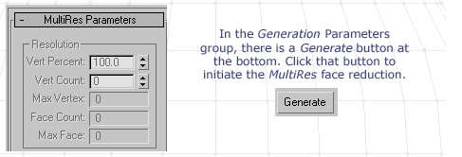

Once the generation is complete, the Resolution group parameters become available for editing. You simply decrease the vertex count or percent by using the spinners or enter the values in the field through the keyboard. Entering about 25 percent gives you an optimization within your goal of 1000 polygons.
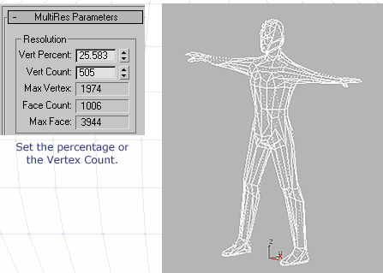
To apply MultiRes to a subobject selection, expand the MultiRes stack, and selectVertex. Then, select the vertices you don't want affected, and click Maintain Base Vertices. Then click the Generate button.

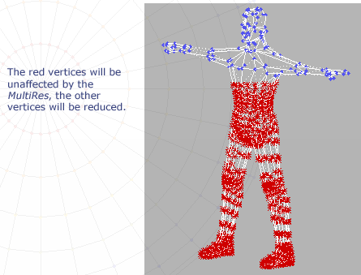

MultiRes supports Vertex Merging between separate elements. If you turn it on, then separate elements will have their vertices welded together if they are within theMerge Threshold. If this vertex-merging feature is not turned on, the different elements are maintained as separate ones, and no welding across elements occurs.
In general, MultiRes provides far superior optimization than does the Optimize modifier, as MultiRes tends to preserve the form of the mesh better. But in both cases, manual optimization is sometimes necessary.
Adding Polygons Using Tesslate/Subdivide/Cut/ Face Creation
Once your optimization is completed, you may find you need to add additional faces into the mesh. Often you won't discover the need for additional geometry until you have skinned, rigged, and animated your character. Then you may see that the character is unable to bend at the knees or elbows, pelvis or shoulders without sharp corners sticking out.
The geometry needs to be divided so it can bend. You can add more faces using the Slice, QuickSlice, or Cut tools as mentioned in last week's lectures. You can also use the Tesselate button in Edit Mesh/Edit Poly to increase the mesh complexity overall on a selection. Use Tesselate to improve general roundness, use the other tools to add geometry for expansion joints.
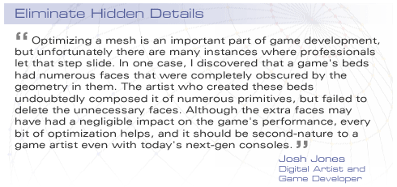

Polygon Reduction—Manual Techniques
The sad truth of the matter is that the best way to do polygon reduction is by hand. As an artist, you have a much better idea of where you will need vertices and edges and where you don't. It can be intimidating to imagine that you are slowly going over the entire surface of your model and painstakingly removing or adding vertices and edges. But that's the job of the artist, namely to work in a slow and methodical way almost as if time itself has stopped. Think of the ancient engravers who would use needles to draw each and every crosshatch in a lithograph illustration.
Weld
The safest and most direct method for polygon reduction is to work at the vertex level and simply weld the vertices to reduce complexity. You can do this process on pairs of vertices or selections of three or four vertices. Be sure to keep Ignore Backfacing turned on, or you can mistakenly select vertices and weld them as well. Adjust the Weld Threshold to a larger value if the Weld operation doesn't work. You can also use the Weld Setting button to launch the Weld dialog to specify the weld threshold.
There is also a Target Weld, which lets you select a vertex and then move it and weld it to another. Click Target Weld, then drag the vertex you want to weld over to the vertex location you want to combine the vertex with.
Remove and Delete
In Editable Mesh, if you select a vertex and delete it, the faces that are attached to the vertex will disappear along with the vertex. There is no way in Edit Mesh modifier/ Editable Mesh object to remove that vertex without affecting the surface.
In Edit Poly, however, you can select a Vertex or Edge and use the Remove button to remove it and still have the surface maintain its integrity. If you remove an edge or vertex, the surface will retriangulate to make up for the missing component. If you remove an edge, the vertices will stay untouched as long as other edges still share them; if you remove all the edges that share a vertex, the vertex will be removed as well.

Controlling Polycount in Loft Objects
In the earlier lecture on Lofting, you created a sort of twisted horn object without concern for the polygon count. If you had the triangle counter up, you might discover that object was over 10,000 tris.
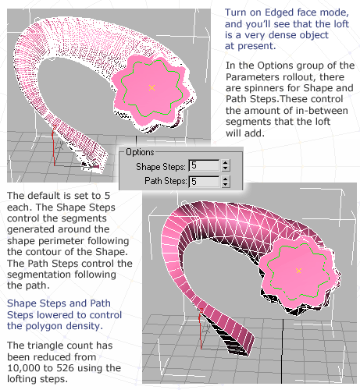
You can model efficiently by drawing your path and shapes in straight line segments and then keep the Shape and Path steps at zero.
Keep the Polygon Counter utility up while you work, so you can see the effect of changing the shape steps. Alternatively, use the Triangle Counter by customizing a Hotkey for a heads-up display in the viewport. Do note that the triangle count is the more accurate measurement of a mesh's complexity.
Editable Poly objects don't measure polygons the same way as Editable Mesh objects do. For example, a standard box, if converted to an Editable Mesh, will appear to be made up of 12 polygons according to the Polygon Counter. If the same geometry is converted to an Editable Poly, the object will appear to be made up of only 6 polygons. Using the Triangle Counter will always yield the same number of triangles in an object.
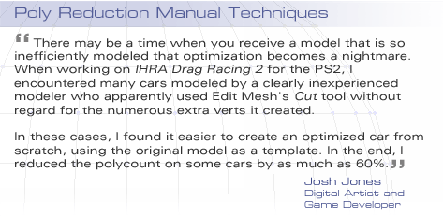
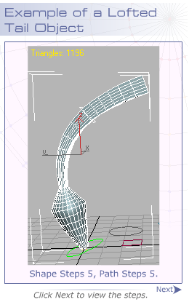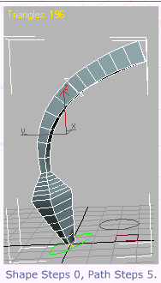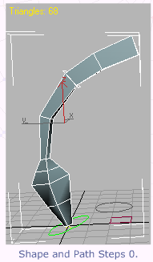

Summary
Congratulations, you have made it to the end of Week 3.
This week, you discussed the most important aspect of low-poly modeling. You discussed in detail various polygon reduction techniques. You learned about the 3ds Max modifiers like optimize and multires and manual techniques like weld, remove and delete, and controlling polygons in loft objects.
Next week, you'll look at how to use image maps to replace detail in characters and their environment. You'll have a chance to see how to use bump mapping and normal mapping to convert simple polygons into what appear to be more complex surfaces. With the advent of DirectX shaders for realtime games, this method is gaining popularity and should become widespread.

Assignment 1: Discussion Questions
By Tuesday, April 20, 2010, respond to the discussion question assigned to you by your facilitator. Submit your responses to the appropriate Discussion Area. Start reviewing and responding to your classmates' discussions as early in the week as possible.
Grading Criteria | Maximum Points
Response Criteria
Met the criteria for the correct responses to the questions assigned. | 6
Used vocabulary relevant to the current week's topics—at least five terms. | 6
Participation Criteria
Used vocabulary relevant to the current week's topics—at least five terms. | 6
Participated in the discussion by asking a question, providing a statement of clarification, providing a point of view with a rationale, challenging a point of discussion, or drawing a relationship between one or more points of the discussion. | 6
Justified ideas and responses by using appropriate examples and references from texts, Web sites, other references, or personal experience. | 6
Total: | 30
For assistance with any problems you may have when completing this assignment—OR—to offer your assistance to classmates, please use theProblems and Solutions Discussion area located through the left side navigation link.
Which areas of the torso require more polygons and which areas can be created using lesser polygons? What techniques will generate higher poly counts and why?
Just one discussion question this week. I look forward to an interesting discussion!
- Todd
Assignment 2: Final Project—Modeling the Body

Adjust the grayscale of your model sheet scans, so that the white drawing background is tinted gray; then use as reference images for your character in 3ds Max viewports. Using a gray background is important, so you can see your drawing lines.
Model your character's torso, arms, legs, hands, and feet.
Post at least three files, showing the process of the modeling over numerous sessions.
Supporting DQ: Which techniques did you use to model your character's torso, arms, legs, hands, and feet? Present an argument in support fusing those techniques. Is there a better way to do it?
By Tuesday, April 20, 2010, post the .MAX files to the appropriate Discussion Area.
Grading Criteria | Maximum Points
Posted scans of the model sheets with gray backgrounds. | 8
Posted .MAX files with the character's torso, arms, legs, hands, and feet. | 5
Posted at least three iterative files showing the work-in-progress. | 8
Mentioned the techniques used for completing the assignment and provided reasons for them. | 4
Total: | 25
For assistance with any problems you may have when completing this assignment—OR—to offer your assistance to classmates, please use theProblems and Solutions Discussion area located through the left side navigation link.
Many of you have been working with your model sheets as reference. Be sure to include that reference in your Max files (post an FBX file too). Also be sure to answer the discussion question. I look forward to reviewing your models!
- Todd

Assignment 3: Final Project—Making the Props
Model your character's props. Try modeling the props using different techniques than you used on your character.
Try to expand your knowledge of 3ds Max techniques here, rather than use the same techniques as before.
Supporting DQ: Discuss the techniques that you used for creating the character's props and why. Give reasons. Is there a better way to do it?
By Thursday, April 22, 2010, save and post as a .MAX file to the appropriateDiscussion Area.
Grading Criteria | Maximum Points
Posted scan with multiple views of the props or weapons. | 10
Posted .MAX files of the weapons or props that use spline modeling techniques. | 5
Mentioned the techniques used for completing the assignment and provided reasons for them. | 10
Total: | 25
For assistance with any problems you may have when completing this assignment—OR—to offer your assistance to classmates, please use theProblems and Solutions Discussion area located through the left side navigation link.
I look forward to reviewing your prop models. Be sure to answer the discussion question!
- Todd
Assignment 4: Reducing the Polygon Count

Review and download the character from the Doc Sharing section. Reduce the polygon count for the character provided to you to 1,000 polygons.
Supporting DQ: Which techniques did you use to reduce the character's poly count and why? Give your reasons.
By Saturday, April 24, 2010 post your character model in .MAX format to the appropriate Discussion Area.
Review and critique the game character posted by at least two other students. Based on the feedback received from your peers, improve the game character by the end of week. Finally, submit the game character to your W3: Assignment 4 Dropbox.
Grading Criteria | Maximum Points
Posted a version of the character set to 1,000 polygons usingMultiRes. | 10
Posted a version of the character set to 1,000 polygons that doesn't use MultiRes, but instead uses Edit Poly object/Editable Poly object. | 5
Mentioned the techniques used for completing the assignment and provided reasons for them. | 10
Total: | 25
For assistance with any problems you may have when completing this assignment—OR—to offer your assistance to classmates, please use theProblems and Solutions Discussion area located through the left side navigation link.
Be sure to read the grading criteria on this one! I look forward to reviewing the results.
- Todd
Assignment 5: Exploring 3ds Max

Explore the 3ds Max toolset on your own. Explore the various features, actions, menus, and options of the software on your own.

By Saturday, April 24, 2010, post your findings and discoveries to the 3ds MaxProblems and Solutions Discussion Area. Also, post the challenges you faced in the entire process and how you tackled those. In addition, also share some tips and best practices with your peers and suggest solutions to the challenges faced by them.
Grading Criteria | Maximum Points
Posted findings and discoveries gained while exploring the 3ds Max toolset. | 4
Actively participated in the 3ds Max Problems and Solutions Discussion Area. | 4
Total: | 8
For assistance with any problems you may have when completing this assignment—OR—to offer your assistance to classmates, please use theProblems and Solutions Discussion area located through the left side navigation link.
Remember that this assignment asks you to explore 3D Studio Max beyond the requirements of your other assignments, and independent of those assignments. Learn something new about the software that will be useful to you, and share it with your classmates.
- Todd

